Sales Buddy App SOP

The following steps outline the procedure for Collection Sales Buddy mobile application
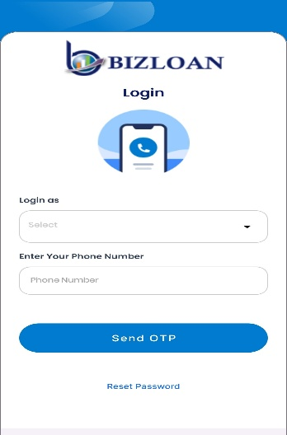

Step 1: Login

Step 1: Open the App
- Launch the BizLoan mobile application.
- You will land on the login screen.
- You will see the "Login as" dropdown and a field to
enter your phone number.

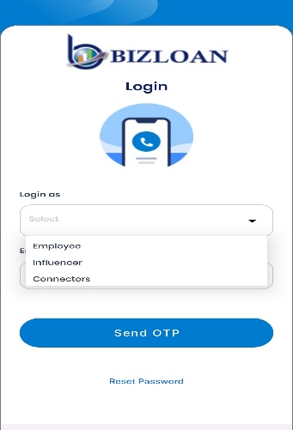

Step 2: Select Login Role
- Tap on the "Select" dropdown.
- Choose your role from the available options:
  - Employee
  - Influencer
  - Connectors

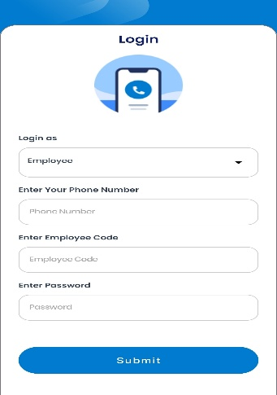

Step 3: Based on Role Selection
- If you select Employee:
- Enter your Phone Number.
- Employee Code.
- Password.
- Tap "Submit" to log in.

Step 4: Reset Password (If needed)
- If you forgot your password, tap on “Reset Password” at the bottom of the
login screen and follow the instruction.

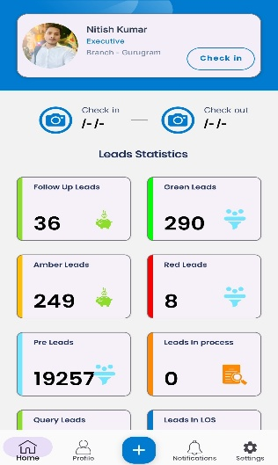

Step 5: Dashboard Overview

Once logged in, you will land on the Home/Dashboard screen:
- User Info Section:
- Your name, designation, and branch location are displayed.
- Leads Statistics:
Displays the count of leads in different categories:

